PHASE 3 – PROJECT DESIGN

Project Title : Implement Client Script & UI Policy (Incident)

1. Introduction

- Project Design describes the structure and working process of the ServiceNow Incident Management project.

- The project uses UI Policies and Client Scripts to control field behavior, automate values, and validate Incident records.

2. System Architecture

The project consists of the following components:

1. ServiceNow Platform
2. Incident Table
3. UI Policy
4. UI Policy Actions
5. onChange Client Script
6. onSubmit Client Script
7. onCellEdit Client Script

3. UI Policy Design

UI Policy Name: High Impact Control

Table: Incident

Condition: Impact is High

Actions:

- Assignment Group – Mandatory
- Urgency – Read-only

Reverse if False: True

4. Client Script Design

A. onChange Client Script

Purpose: Automatically set Urgency to High when Impact is High.

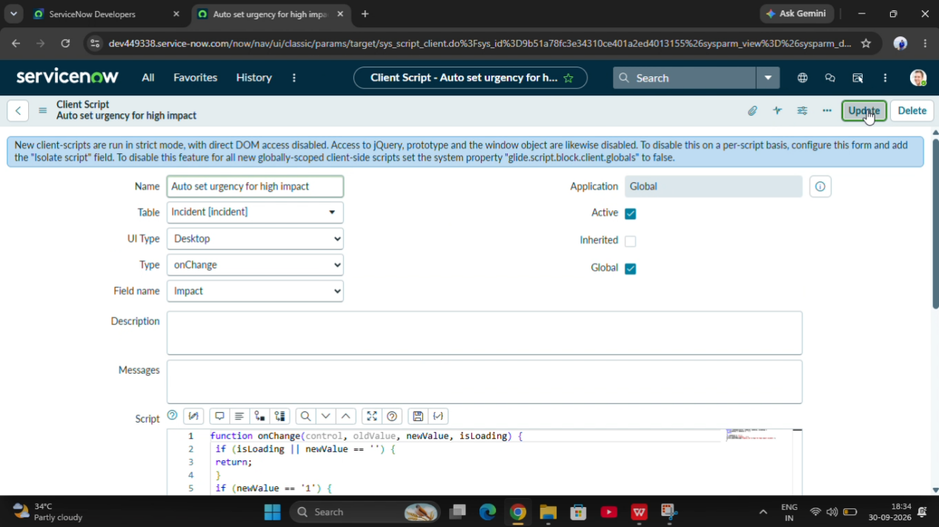

B. onSubmit Client Script

Purpose: Prevent saving a High Impact Incident when Assigned To is empty.
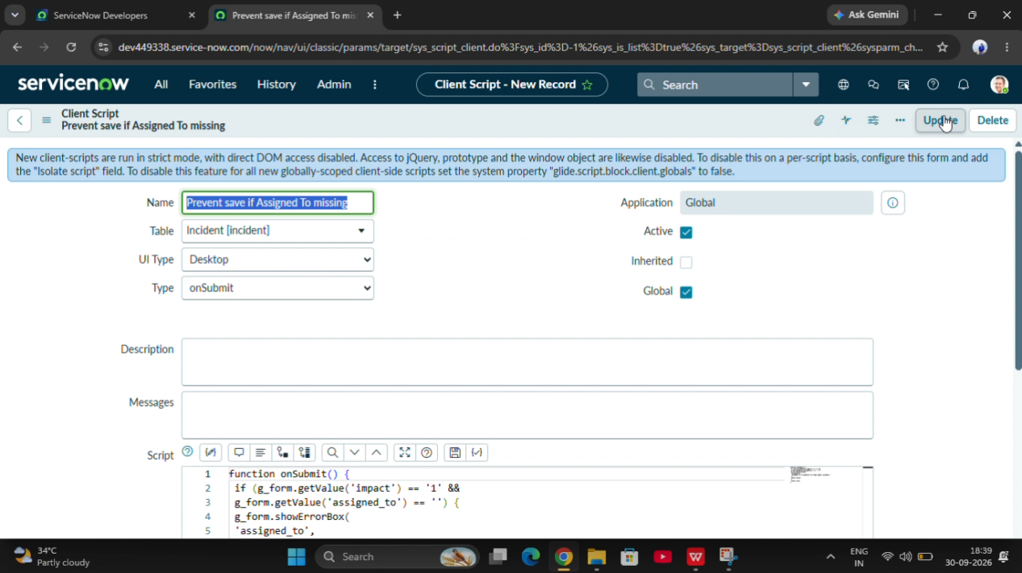

C. onCellEdit Client Script

Purpose: Prevent State changes through direct list editing.

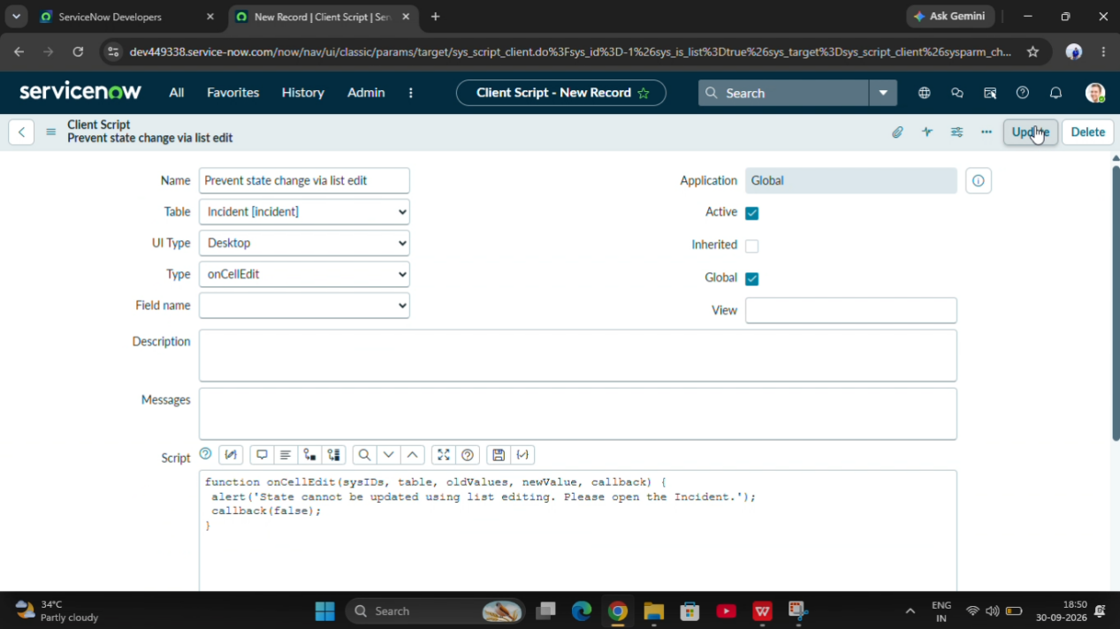

5. Project Workflow

1. User opens the Incident form.
2. User selects the Impact value.
3. UI Policy checks the Impact condition.
4. If Impact is High, configured field actions are applied.
5. onChange Client Script automatically sets Urgency to High.
6. When the user submits the record, onSubmit validates Assigned To.
7. If validation fails, saving is prevented.
8. If validation passes, the record can be saved.
9. State list editing is restricted through onCellEdit.

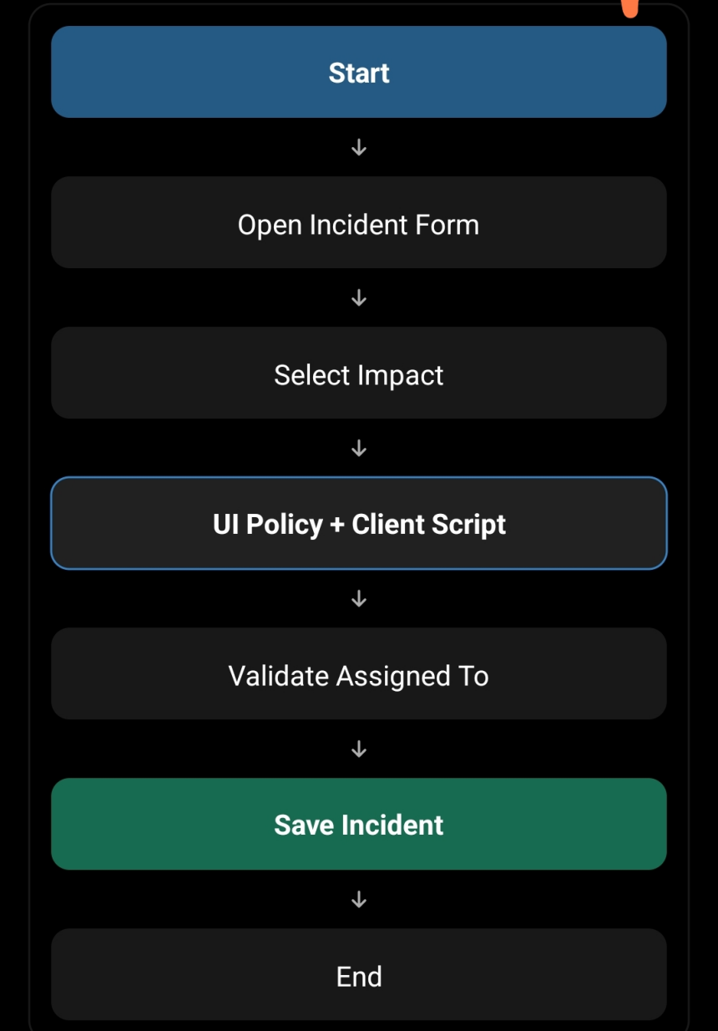

6. Expected Output

- The system should provide conditional field behavior, automatic urgency updates, mandatory field validation, and restricted list editing.

7. Conclusion

- The design provides a structured approach for implementing Incident Management controls using ServiceNow UI Policies and Client Scripts.

